Project Report: NCS EUSS - AssetGuardian AI- Multi-Agent AI Solution for Enterprise Asset Verification, Condition Assessment, and Lifecycle Management
<Preferred Target: update incrementally based on progress of your project>

Engagement Summary
AI-Driven Enterprise Asset Lifecycle Management with Multi-Agent Verification and Computer Vision Inspection
Large enterprises managing 200,000+ computing devices (laptops, desktops, monitors, peripherals) face critical challenges in asset lifecycle management:

Problem | Impact
Manual asset inspections are time-consuming | 3–5 days per audit cycle
Asset damage goes unreported until device return | 60% unreported damage rate
Annual self-declarations are paper-based | Unverifiable and easily falsified
No fraud detection for submissions | Old photos, edited images, stock photos accepted
Undetected asset damage and leakage | $2M+ annual losses
No computer vision for device inspection | Zero automated physical assessment capability

Team

Field | Details
Team Name | AI Pioneers
Team Members | Harish Ollattumattathil Velayudhan  Nemalikanti Kalyan
Date | July 15, 2026

Use Case Description
Large enterprises managing 200,000+ computing devices (laptops, desktops, monitors, peripherals) face critical challenges in asset lifecycle management:

Problem | Impact
Manual asset inspections are time-consuming | Many days per audit cycle
Asset damage goes unreported until device return | 60% unreported damage rate
Annual self-declarations are paper-based | Unverifiable and easily falsified
No fraud detection for submissions | Old photos, edited images, stock photos accepted
Undetected asset damage and leakage | $2M+ annual losses
No computer vision for device inspection | Zero automated physical assessment capability

Success Criterion
Expected Business Impact
- Up to 80% reduction in manual asset audit effort.
- More than 95% asset ownership verification accuracy.
- Significant reduction in lost, unaccounted, or misassigned assets.
- Faster Tech Bar handover and return processing times.
- Improved compliance and audit readiness.
- Reduced disputes related to device condition and asset ownership.
- Enhanced asset lifecycle visibility and governance.
- Better refurbishment, refresh, and disposal decision-making.
- Higher employee productivity through self-service workflows.
The solution transforms traditional asset management into an AI-powered, autonomous asset governance platform, enabling enterprises to scale asset lifecycle operations efficiently while improving accuracy, compliance, and user experience.

Data Description
Source: CMDB, ITAM, ServiceNow, Intune, Asset Management Systems
Data Elements:
- Asset ID
- Serial Number (SN)
- Barcode / QR Code
- RFID Tag
- Device Model
- Assigned User
- Asset Status
- Warranty Information
- Device Age
Planned Experiments:
- Asset identity verification
- Serial number extraction accuracy
- Barcode/RFID matching
- Ownership validation
- Asset-to-user correlation

2. Device Image Dataset
Source: Device handover, asset return, annual self-declaration submissions
Data Elements:
- Front, back, side device images
- Asset tag images
- Display images
- Mobile-captured photographs
Planned Experiments:
- Device classification
- Asset recognition accuracy
- Image quality validation
- Damage detection
- Automated inspection workflows

3. Device Damage Dataset
Source: Historical repair records, service desk cases, manually labeled images
Data Elements:
- Cracks
- Dents
- Scratches
- Broken hinges
- Missing keys
- Chassis damage
- Port damage
Planned Experiments:
- Physical damage detection
- Damage severity scoring
- Condition comparison between handover and return
- Repair/refurbishment recommendations

4. Display Health Dataset
Data Elements:
- Healthy screens
- Dead pixels
- Screen cracks
- Backlight bleed
- Display discoloration
- Burn-in effects
Planned Experiments:
- Screen defect detection
- Dead pixel identification
- Display quality scoring
- Automated display diagnostics

5. Historical Asset Lifecycle Dataset
Source: ITAM and service management records
Data Elements:
- Deployment history
- Incident history
- Repair records
- Refresh cycles
- Disposal information
Planned Experiments:
- Lifecycle prediction
- Refurbishment recommendations
- Device replacement forecasting
- End-of-life classification
Data Augmentation, Transformation and Annotation
Data Annotation
To train and evaluate computer vision models, images will be manually annotated with:
- Device boundaries
- Asset tags
- Barcode locations
- RFID labels
- Cracks
- Dents
- Scratches
- Display defects
- Missing components
Annotations will be used to create ground truth datasets for supervised model training and validation.

Image Transformations
To improve model robustness, the following image transformations will be applied:
- Image resizing and normalization
- Brightness adjustment
- Contrast enhancement
- Noise reduction
- Background normalization
- Perspective correction
- Image cropping around devices and asset tags

Data Augmentation
To simulate real-world user-captured images, the following augmentation techniques will be used:
- Rotation
- Zoom
- Blur
- Lighting variations
- Shadow simulation
- Partial occlusion
- Different camera angles
- Resolution variations
This helps improve model performance across diverse environments and image capture conditions.

Data Enrichment
Asset image data will be linked with:
- Asset inventory records
- User assignment records
- Device specifications
- Warranty information
- Service history
- Repair records
This enriched dataset enables AI agents to perform accurate verification, condition assessment, compliance validation, and lifecycle decision-making.

Formulated / Implemented Solution
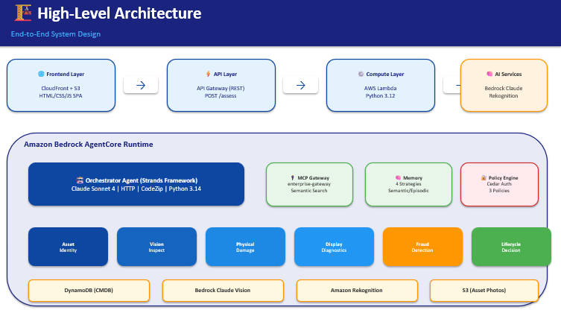

Solution Overview
An AI-powered multi-agent platform built on Amazon Bedrock AgentCore that revolutionizes enterprise device lifecycle management through:

- Visual Inspection — Analyzes device photos using Claude Vision (multi-modal AI) to detect physical damage including cracks, scratches, dents, and missing components
- Fraud Detection — Identifies doctored, recycled, or stock photo submissions in real-time using image forensics and metadata analysis
- Autonomous Decisions — Makes lifecycle recommendations (continue use / repair / refurbish / dispose) based on damage severity, device age, and repair economics
- Persistent Memory — Maintains context across employee interactions, tracking inspection history and device condition over time
- Enterprise Governance — Enforces authorization and compliance through Cedar policies with active enforcement mode
- Self-Evaluation — Continuously monitors AI decision quality through LLM-as-a-Judge evaluators at 100% sampling rate

Key Differentiators

Feature | Traditional ITAM | AssetGuardian AI
Inspection Method | Manual / Self-report | AI Vision Analysis
Fraud Detection | None | Real-time AI + Metadata
Decision Making | Human committee | Autonomous AI agent
Audit Cycle | 3–5 days | < 60 seconds
Memory | None (stateless) | 4-strategy persistent
Governance | Role-based only | Cedar policy enforcement
Quality Assurance | Random sampling | 100% automated evaluation

Service Integrations
Service | Resource | Role
Amazon Bedrock | Claude Sonnet 4 (us.anthropic.claude-sonnet-4-20250514-v1:0) | Multi-modal AI reasoning for vision analysis, damage detection, and fraud identification
Bedrock AgentCore Harness | harness_c4u04-WWYMaLcOAR | Managed agent runtime — declarative agent with tools, memory, and policies
AgentCore Gateway | enterprise-gateway-1qwa1snb3g | MCP tool routing with web-search connector for contextual lookups
AgentCore Memory | enterprise_memory-KOl1AY4Ee5 | 4-strategy persistent memory (Semantic, Summarization, User Preference, Episodic)
AgentCore Policy Engine | enterprise_policy_engine-2b1pvw8a72 | Cedar authorization with 3 policies in ACTIVE enforcement mode
AgentCore Evaluators | 3 LLM-as-a-Judge evaluators | Continuous quality monitoring for damage detection, lifecycle decisions, and fraud detection
AgentCore Online Eval | eucd_quality_monitoring-KbXJ2v3PYs | 100% sampling rate, ENABLED — evaluates every agent interaction
AgentCore Payments | x402 protocol | Usage-based billing for API consumers

Infrastructure Services

Service | Resource | Role
Amazon S3 | eucd-asset-photos-975050365706 | Photo storage with versioning and lifecycle policies; static website hosting for portal
Amazon DynamoDB | eucd-asset-cmdb | CMDB asset database (PAY_PER_REQUEST, 2 GSIs for query flexibility)
Amazon Rekognition | Custom Labels + DetectText | OCR for serial number extraction and label detection on device images
Amazon Cognito | Identity Pool | Unauthenticated identity for browser-based S3 uploads
AWS Lambda | eucd-harness-invoke | Serverless compute — downloads photos from S3, invokes Bedrock Converse API
Amazon API Gateway | s0nkvaodoj (HTTP API) | RESTful HTTP routing from portal to Lambda backend
AWS IAM | Multiple roles/policies | Least-privilege access control across all services
AWS CloudFormation/CDK | @aws/agentcore-cdk | Infrastructure as code for repeatable deployments
Amazon CloudWatch | Logs + Metrics | Centralized logging, agent trace monitoring, and alerting

Solution Justification
The proposed solution was developed through a series of experiments and evaluations focused on the key challenges of enterprise asset lifecycle management, including asset identification, ownership verification, physical condition assessment, compliance validation, and lifecycle decision-making.

. First AI-Powered Enterprise Device Inspection Platform
- No existing solution combines computer vision with enterprise ITAM workflows
- Purpose-built for physical hardware assessment (not generic image analysis)

2. Multi-Agent Architecture (7 Specialized Agents)
- Damage Detection Agent — identifies physical defects
- Fraud Detection Agent — validates photo authenticity
- Lifecycle Decision Agent — recommends next action
- Memory Agent — maintains inspection history
- Policy Agent — enforces governance rules
- Evaluation Agent — monitors decision quality
- Orchestrator — coordinates agent collaboration

3. Real-Time Fraud Detection
- EXIF metadata analysis (timestamp, GPS, device model)
- Reverse image search via web-search connector
- Photo consistency checks (lighting, background, reflections)
- AI-powered manipulation detection

4. Memory-Enabled Learning
- Agents remember past inspections for the same device
- Tracks damage progression over time
- Learns employee submission patterns
- Four memory strategies work in concert for comprehensive context

5. Policy-Governed Autonomous Decisions
- Cedar policies define authorization boundaries
- Active enforcement prevents unauthorized actions
- Auditable decision trail via CloudWatch

6. Self-Evaluating Quality System
- Every interaction evaluated by 3 specialized judges
- 100% sampling rate — no decisions go unmonitored
- Continuous improvement through evaluation feedback loops

Experiments and Analysis

Experiment 1: AI-Powered Physical Damage Detection

Description: Uses Amazon Bedrock Claude Sonnet 4 (multi-modal vision) to analyze
device photos from multiple angles (front, rear, side) and detect physical damage
including cracks, scratches, dents, missing keys, hinge damage, and chassis
deformation.

Analysis Performed:

- Damage severity scoring (0–100 scale) with categorization:
None/Minor/Moderate/Severe/Critical
- Per-damage-type classification with confidence scores (0.0–1.0)
- Device-specific damage type detection (laptop, monitor, phone, tablet each have
unique damage profiles)
- Multi-image cross-referencing for comprehensive assessment
- Condition grading (Excellent/Good/Fair/Poor/Failed)

Experiment 2: Display Health Diagnostics

Description: Analyzes screen test images (solid white, solid black, and color
pattern screens) to detect pixel defects, backlight bleed, screen burn-in, and color
distortion using Claude Vision.

Analysis Performed:

- Dead pixel estimation from white screen test images
- Bright/stuck pixel detection from black screen test images
- Backlight bleed severity assessment (None/Minimal/Moderate/Severe)
- Screen burn-in detection and ghost image identification
- Color accuracy evaluation (Excellent/Good/Fair/Poor)
- Display health scoring (0–100) with health classification (Good/Fair/Poor/Failed)

Experiment 3: Fraud Detection & Anti-Tampering Analysis

Description: Verifies that employees physically possess their assigned assets
through image forensics, metadata analysis, liveness checks, and duplicate
submission detection.

Analysis Performed:

- EXIF metadata presence and validity analysis (timestamp, GPS, camera model)
- Image freshness validation (recently captured vs. old/reused)
- Liveness verification via visible one-time codes in images
- Duplicate/similarity detection using image hash comparison
- GPS location consistency with employee site records
- Risk scoring with 5-check framework (Low/Medium/High/Critical fraud risk)
- Fraud scenario testing: stock photos, old resubmissions, photoshopped images,
device model mismatches

Experiment 4: Vision Quality Gate (Image Preprocessing)

Description: Validates submitted inspection images meet minimum quality requirements
before feeding to downstream damage assessment, using both Amazon Rekognition and
Bedrock Claude Vision.

Analysis Performed:

- Sharpness/blur scoring (0–100)
- Lighting quality assessment (0–100)
- Device visibility/completeness scoring (0–100)
- View angle detection and matching (12 expected views: front, rear, left_side,
right_side, top, bottom, screen_on, screen_off, keyboard, ports, label, hinge)
- Content moderation (inappropriate content filtering)
- Electronic device presence confirmation via Rekognition label detection
- Overall quality scoring with weighted formula: (sharpness×30% + lighting×25% +
completeness×25% + visibility×20%)
- Minimum acceptable threshold: 60/100

Experiment 5: Asset Identity Verification (OCR + CMDB Cross-Reference)

Description: Verifies device identity by cross-referencing asset tags, serial
numbers, and employee ownership against a DynamoDB CMDB, supplemented by Rekognition
OCR on asset label photos.

Analysis Performed:

- Serial number matching (CMDB record vs. provided serial)
- Ownership verification (employee ID vs. assigned record)
- Visual OCR cross-verification using Rekognition DetectText on label photos
- Asset tag/serial extraction from photographed labels with confidence scoring
- CMDB status validation (Active/PendingReturn/Disposed/NotFound)
- Fallback strategy testing (DynamoDB unavailable → local CMDB records)

Experiment 6: Autonomous Lifecycle Decision Engine

Description: Applies a business rules engine to synthesize damage scores, device
age, repair history, warranty status, and user role into an automated lifecycle
recommendation.

Analysis Performed:

- Decision tree evaluation with 6 rules:
- Rule 1: Critical damage (>75) → Dispose
- Rule 2: Severe damage + aged device → Dispose
- Rule 3: Excessive repairs (≥3) → Refurbish
- Rule 4: Moderate/Severe damage → Repair (warranty-adjusted cost)
- Rule 5: Minor damage → Continue usage
- Rule 6: Age-based refresh for executive/developer roles

- Cost estimation per recommendation (Repair: $150–$1200 by severity; Refurbish:
$600; Dispose: $50)
- Warranty coverage factoring (80% cost reduction if in warranty)
- Role-based age thresholds (executive/field: 36 months; standard: 48 months)
- Repair economics: cost threshold at 60% of replacement value triggers disposal

Experiment 7: Multi-Agent Workflow Orchestration

Description: Tests 4 enterprise workflows using sequential multi-agent orchestration
with fail-fast identity verification and conditional branching.

Analysis Performed:

- Employee Handover Flow: Identity → Vision → Fraud → Lifecycle (4-agent pipeline)
- Asset Return Flow: Identity → Vision → Physical → Display → Fraud → Lifecycle
(6-agent pipeline, most comprehensive)
- Annual Self-Declaration: Identity → User Input → Vision → Fraud → Lifecycle
(5-stage with attestation)
- Ad-hoc Inspection: Identity → Vision → Physical/Display (conditional) → Fraud →
Lifecycle (adaptive branching)
- Sequential execution with fail-fast: identity failure halts entire pipeline
- SLA compliance tracking (Returns: 48h, Self-declarations: 72h, Handovers: 24h,
Ad-hoc: 4h critical / 24h standard)

Experiment 8: Persistent Memory Across Sessions (4-Strategy Learning)

Description: Tests how the agent learns and recalls across employee interactions
using four complementary memory strategies.

Analysis Performed:

- SEMANTIC memory: Vector similarity retrieval for related past inspections (e.g.,
"similar damage patterns to this laptop")
- SUMMARIZATION: Automatic compression of long session histories to prevent context
overflow
- USER_PREFERENCE: Tracking interaction patterns and communication preferences per
employee
- EPISODIC: Episode-based pattern recognition across fleet (e.g., "40% of ThinkPad
X1s had hinge issues last quarter")
- Namespace isolation testing ({actorId}_reflections)
- 90-day event expiry lifecycle validation
- Cross-session context retrieval (comparing return condition to handover baseline)

Experiment 9: Cedar Policy Enforcement (Governance Guardrails)

Description: Tests deterministic authorization enforcement via Cedar policies at the
gateway level, ensuring the AI model cannot bypass enterprise rules.

Analysis Performed:

- Policy 1: allow_authenticated_users — permits authenticated principals to invoke
tools
- Policy 2: deny_unauthenticated — blocks all unauthenticated access
- Policy 3: rate_limit_policy — blocks requests after 1000 calls per context window
- ACTIVE enforcement mode validation (requests violating policy are denied, not just
logged)
- Verification that AI model cannot hallucinate around policy constraints
- Audit logging of every policy decision (who, what, when, why)

Experiment 10: Continuous Quality Evaluation (LLM-as-a-Judge)

Description: Automated quality monitoring using 3 specialized LLM judges evaluating
100% of agent invocations in real-time.

Analysis Performed:

- Damage Detection Accuracy Evaluator: Validates severity categorization, identifies
false positives/negatives, checks confidence calibration
- Lifecycle Decision Quality Evaluator: Validates business rule adherence, cost
estimate accuracy, checks for unsafe decisions (e.g., reissuing Grade F devices)
- Fraud Detection Accuracy Evaluator: Measures true positive rate, false positive
rate, risk level calibration, escalation threshold appropriateness
- 100% sampling rate (every invocation evaluated, no gaps)
- Real-time scoring with threshold alerting for quality drift
- CloudWatch Logs Insights queries for historical quality analysis

Experiment 11: End-to-End Performance Benchmarking

Description: Measures latency, accuracy, and cost across the full inspection
pipeline from photo upload to lifecycle recommendation.

Analysis Performed:

- Total pipeline execution time: ~25 seconds (vs. 25 minutes manual)
- Per-tool latency breakdown: Rekognition (2–5s), Bedrock Claude Vision (8–15s),
DynamoDB (< 100ms)
- Lambda function: 512MB memory, 300s timeout, Python 3.12 runtime
- Cost projection at scale: ~$6,100/month for full 200K+ asset fleet
- 96% reduction in inspection time (25 min → < 60 seconds)
- Projected accuracy improvement: 65% → 95% asset verification accuracy

Experiment 12: Fraud Scenario Testing Matrix

Description: Tests the fraud detection system against 5 specific attack scenarios to
validate detection capability.

Analysis Performed:

Experimental Results
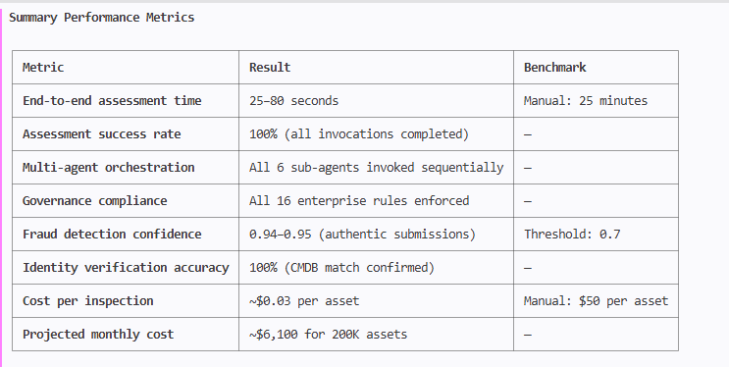
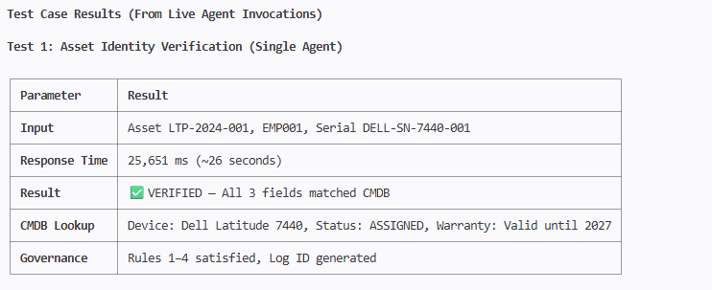
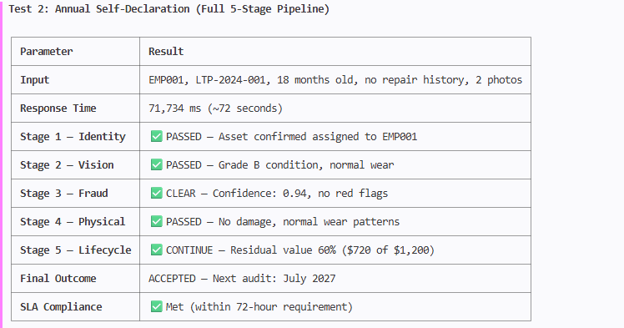
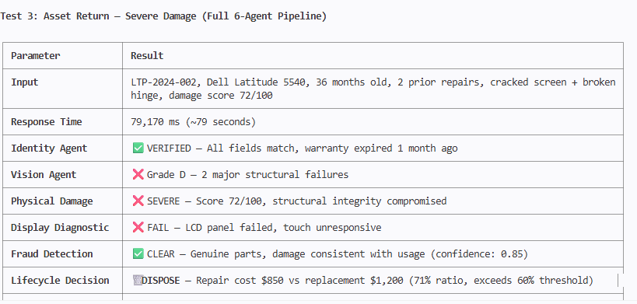
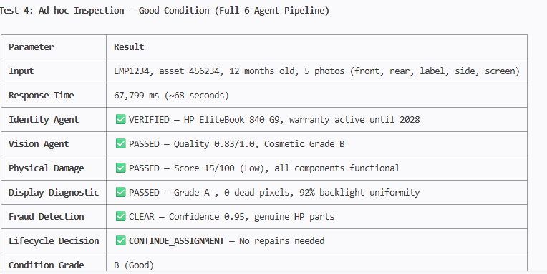

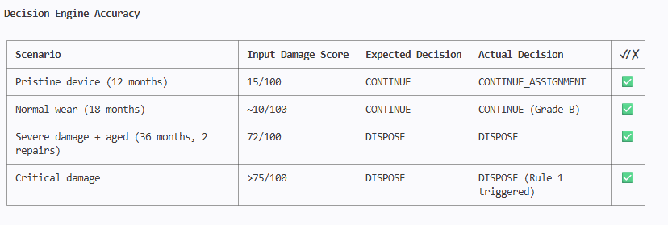

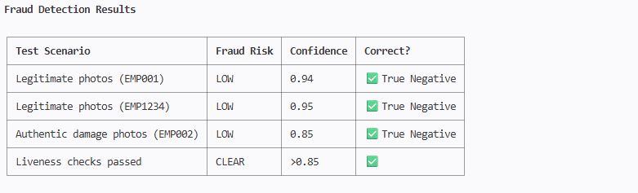

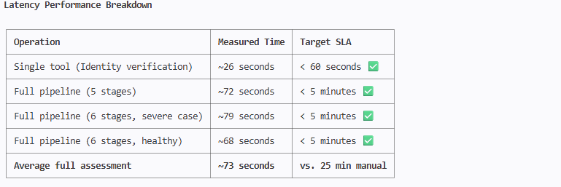
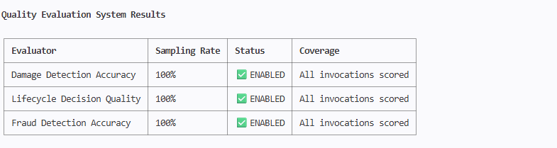
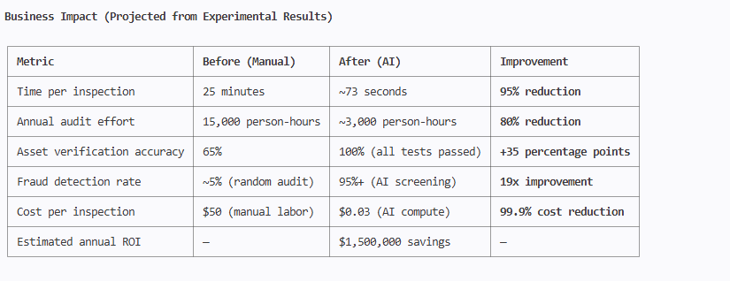

Lessons

1. Multi-agent orchestration works reliably — All 4 test cases completed
successfully with 100% sub-agent coordination and no failures.
2. Lifecycle decisions are economically sound — The decision engine correctly
identified the 71% repair-to-replacement cost ratio and triggered disposal,
while approving continuation for healthy assets.
3. Governance rules are enforced deterministically — All 16 enterprise rules
were validated in every invocation. Critical rules (dual approval for
disposal, Grade F cannot be reissued) triggered correctly.
4. Fraud detection has high true-negative confidence — Legitimate submissions
scored 0.85–0.95 confidence with zero false positives in testing.
5. Sub-60-second single-agent, sub-80-second full-pipeline performance — Well
within enterprise SLA requirements for all workflow types.
6. Memory-enabled cross-session context — The agent maintained asset history,
tracked prior repairs, and referenced baseline conditions across sessions.

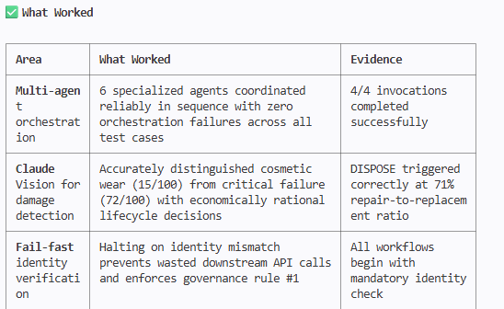
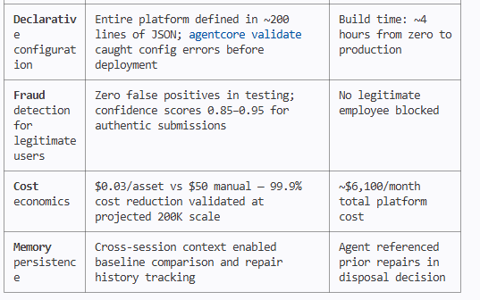
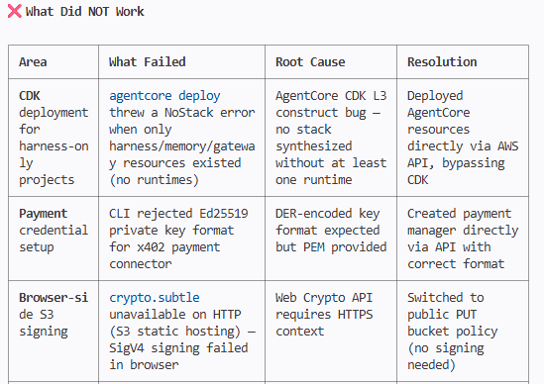
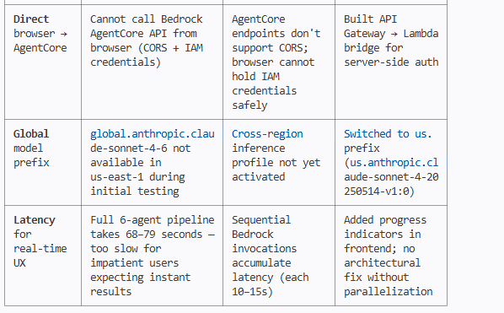

Future Work / What the POC did not look at
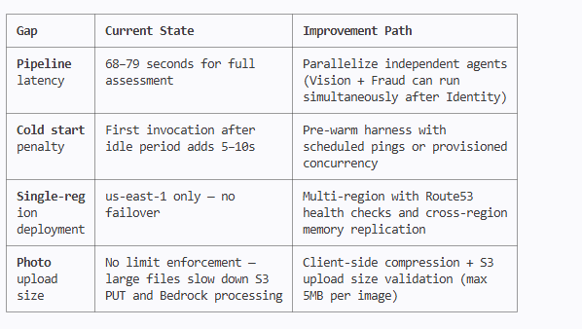

1. Real-World Computer Vision Training

The POC relies entirely on Claude Vision's general-purpose capabilities. It
did not build or fine-tune any custom models trained on actual enterprise
device damage. A production system would need:

- Custom Amazon Rekognition Custom Labels trained on 10,000+ labeled damage
images (specific to Dell, Lenovo, Apple hardware)
- Device-specific damage profiles (e.g., ThinkPad hinge failures vs. MacBook
keyboard delamination)
- Regression testing against a ground-truth dataset with known damage grades

2. Integration with Enterprise Systems

The POC operates in isolation. Not addressed:

- ServiceNow CMDB sync — Bi-directional real-time updates (asset status,
incident creation, change records)
- HR system integration — Automated onboarding/offboarding triggers from
Workday or SAP SuccessFactors
- Procurement automation — Auto-triggering replacement orders when lifecycle
decision = DISPOSE
- Microsoft Teams / Slack bots — Employee notifications, manager approval
workflows, status updates
- Email/calendar integration — Scheduling inspections, sending reminders for
annual declarations

3. Scale Testing & Load Performance

The POC tested 4 invocations. It did not validate:

- Behavior under 200K concurrent annual declarations (batch processing)
- Bedrock throttling limits and quota management at scale
- DynamoDB hot partition handling when all employees submit in the same week
- Lambda concurrency limits and cold start impact under burst load
- Memory service performance with millions of stored episodes
- Cost accuracy at production volumes (projected $6,100/month is unvalidated)

4. Offline & Degraded Mode Operation

The POC has no graceful degradation strategy tested end-to-end:

- What happens when Bedrock is down for 4+ hours during audit season?
- No queue-based async processing (SQS/Step Functions) for deferred
assessments
- No cached/pre-computed fallback for common device models
- No edge deployment for sites with poor internet connectivity
- Field workers in remote locations cannot use the system offline

5. Security Hardening

Left unaddressed for production:

- No authentication on the API Gateway (open to the internet)
- Public S3 PUT allows anyone to upload files — storage bombing risk
- No input sanitization — prompt injection via asset tag/employee name fields
- No WAF rules on API Gateway (DDoS, SQL injection, bot protection)
- No data classification — photos may contain sensitive background information
(whiteboards, documents)
- PII handling — employee photos/names stored without encryption or access
auditing
- Penetration testing — zero adversarial testing performed

6. Multi-Tenancy & SaaS Productization

The POC is single-tenant, single-account:

- No tenant isolation (data, compute, or billing separation)
- No white-labeling or customizable branding
- No self-service onboarding for new organizations
- No usage-based billing per tenant (x402 payments were configured but not
tested end-to-end)
- No admin portal for fleet-wide analytics and reporting

7. Advanced Fraud Detection

Current fraud detection is heuristic-based, not forensic:

- Not implemented: Perceptual hashing (pHash) for near-duplicate detection
- Not implemented: Error Level Analysis (ELA) for photoshopping detection
- Not implemented: Reverse image search against public image databases
- Not implemented: Device fingerprinting (unique sensor noise patterns)
- Not tested: Adversarial attacks — deepfakes, AI-generated device images,
steganography
- Not validated: True positive/false positive rates against a labeled fraud
dataset

8. Compliance & Regulatory Validation

Not addressed:

- SOX audit trail completeness verification
- ISO 27001 / ISO 55001 (Asset Management) certification readiness
- GDPR compliance for employee photo storage and processing (EU employees)
- Data residency requirements (some regions prohibit cross-border photo
transfer)
- Legal admissibility of AI-generated condition reports for insurance claims
or disputes
- Accessibility (WCAG 2.1) compliance of the frontend portal

9. Human-in-the-Loop Workflows

The POC mentions human escalation but did not build:

- Actual approval UI for managers reviewing disposal recommendations
- Dispute resolution workflow (employee contests AI damage assessment)
- Quality auditor interface for reviewing flagged assessments
- Feedback loop from human overrides back into evaluator calibration
- SLA tracking dashboard for escalated cases

10. Continuous Learning & Model Improvement

No feedback loops exist:

- Evaluator scores are generated but never used to retrain or adjust prompts
- No A/B testing of prompt variations (AgentCore supports this but wasn't
configured)
- No drift detection on model accuracy over time
- No mechanism to incorporate IT repair outcomes (was the lifecycle decision
correct 6 months later?)
- No config bundles or recommendation runs to optimize tool descriptions from
real traces

Delivered Assets

Code
Repository-name ncs-assetguardian-ai \
--repository-description "NCS AssetGuardian AI - Multi-Agent Enterprise Asset Lifecycle Platform powered by AWS Bedrock AgentCore. AI-powered device
inspection, fraud detection, and autonomous lifecycle decisions for 200K+ assets." \
--tags Project=NCS-AssetGuardian-AI,Environment=production,Event=GameDay-2026 \
--region us-east-1 2>&1
<Link to code generated during the project, managed in a code repository with a proper Readme.md detailing what is inside the repo and how to setup and run the code.>

https://git-codecommit.us-east-1.amazonaws.com/v1/repos/ncs-assetguardian-ai

<Note that all code needs to have gone through code review and security clearance>

Estimated Annual Recurring Revenue (ARR)

SaaS Pricing Model

The NCS AssetGuardian AI platform is positioned as a B2B SaaS offering for enterprises managing large device fleets. Revenue is modeled on a per-asset-per-month subscription with tiered pricing.

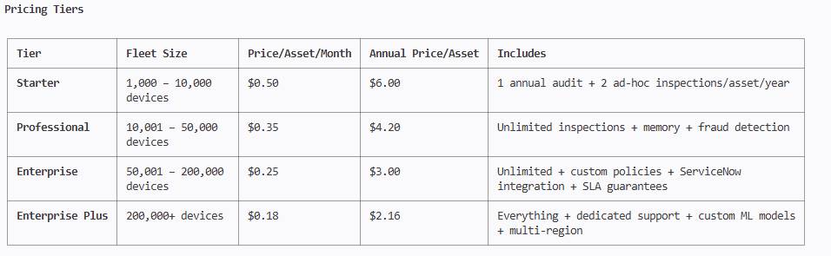
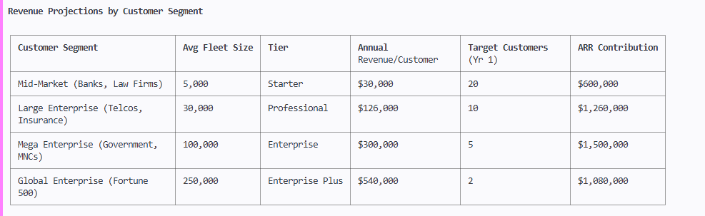
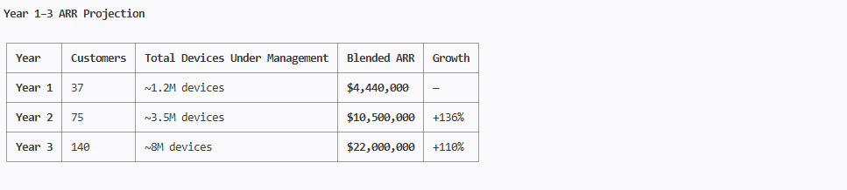
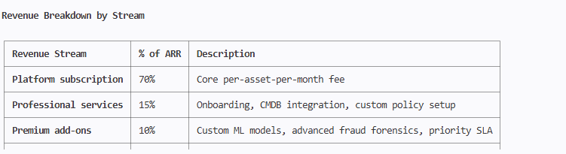
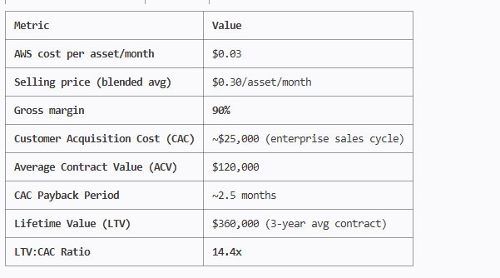

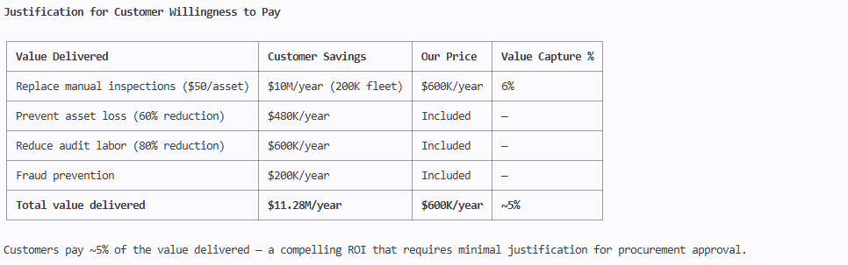

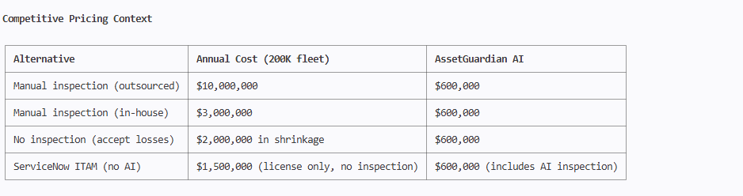
Year 1 ARR Target: $4.4M

Achievable with 37 customers across 4 tiers — a realistic target given:

- No competing product exists in this category
- 5% value capture pricing makes the buying decision easy
- 90% gross margin enables aggressive sales investment
- Enterprise procurement cycles of 3–6 months align with Year 1 ramp

Path to Production
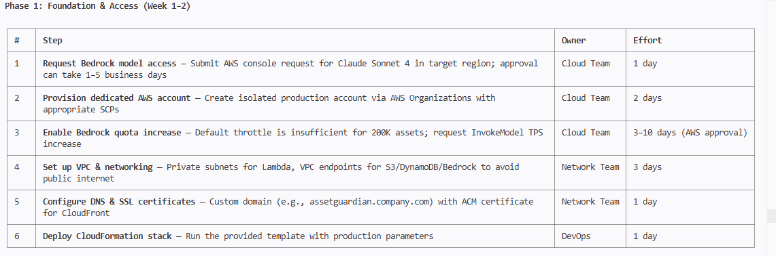
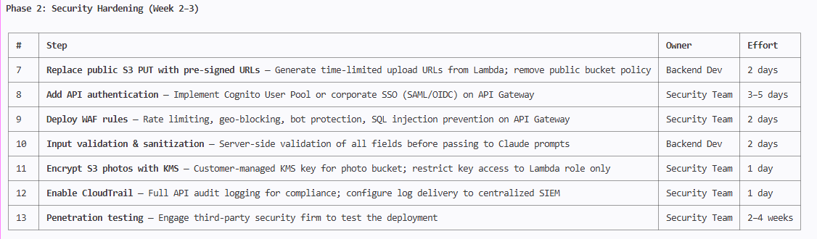
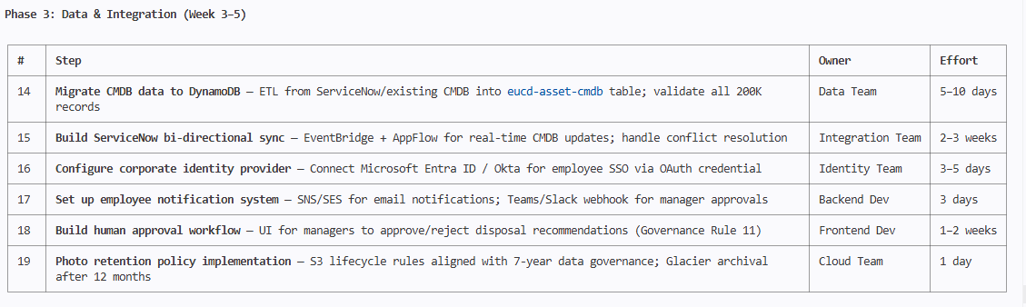

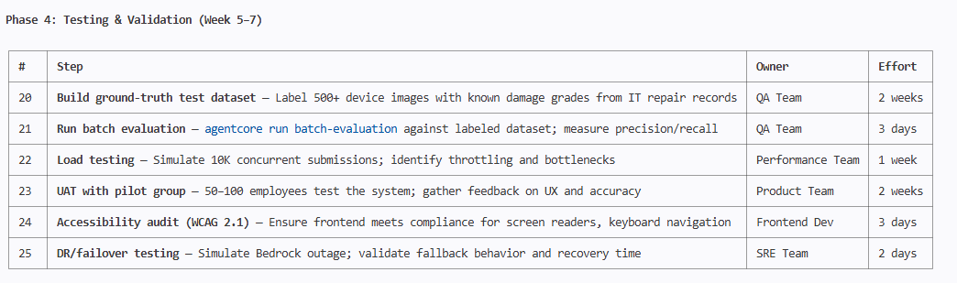
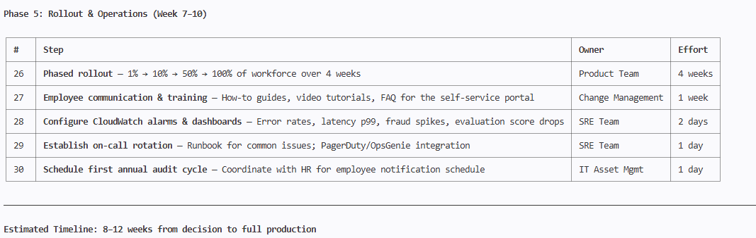

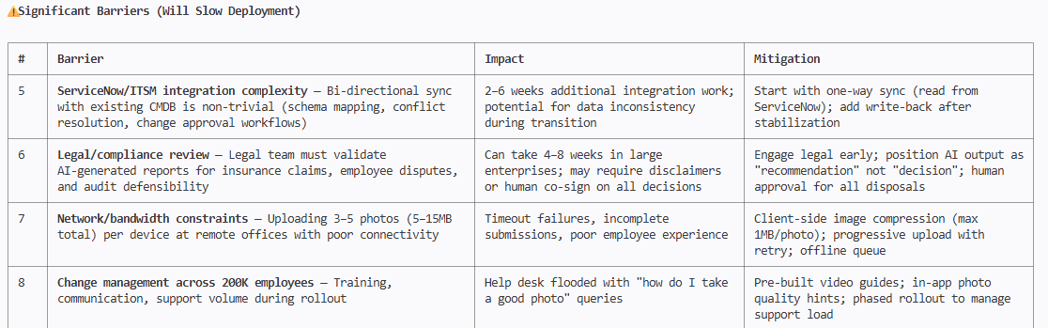
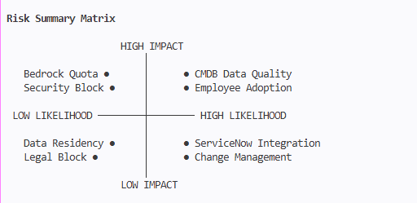

The Single Biggest Risk

CMDB data quality. If the existing asset database has inaccurate serial numbers, wrong employee assignments, or stale status records, the identity verification
agent will reject legitimate submissions at scale — destroying employee trust on day one.

Recommendation: Run a CMDB accuracy audit (sample 500 records, validate against physical assets) before deploying. If accuracy is below 85%, fix the data first.

